AP Biology Lab Review

Lab - Diffusion and Osmosis

What You Must Know:
Factors that affect diffusion across the membrane
How is water potential measured and its relationship to solute concentration and pressure potential of a solution?
How does molarity relate to osmotic concentration?
How to determine osmotic concentration of a solution from experimental data.
Science Practices - Can You:
Design an experiment to measure the rate of osmosis in a model system?
Analyze data and make predictions about molecular movement through cellular membranes?
Connect the concepts of diffusion and osmosis to the structure of the membrane and molarity?
Use the principles of water potential to predict and justify the movement of water into plant tissue?

*Zucchini cores were placed in sucrose solution at 27C resulted in the following percent changes after 24 hours.
% change in mass | Sucrose Molarity
20% | Distilled Water
10% | 0.2M
-3% | 0.4M
-17% | 0.6M
-25% | 0.8M
-30% | 1.0M

Graph the data on the axes provided. You must determine what
variable is IDV and DV. Be sure to label the graph correctly.

1. What is the solute potential of the zucchini cells? __________
2. What is the water potential of the zucchini cells? __________
3. If the water potential of the soil around the zucchini was - .14 Mpa,
which way would water move? ____________
4. In beaker b, shown in figure 4.4, what is the water potential of the
distilled water in the beaker and of the beet core?
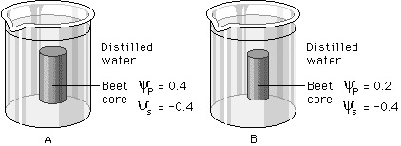

Lab – Enzymes

What You Must Know:
The factors that affect the rate of an enzyme reaction such as temperature, pH and enzyme concentration.
How the structure of an enzyme can be altered and how pH and temperature affect enzyme function.
Science Practices - Can You:
Design a controlled experiment to measure the activity of a specific enzyme under varying conditions?
Use math to calculate the rate of a reaction from a graph or data chart?
Predict and justify how changing an environmental factor would alter an enzyme’s activity.

- What enzyme was tested in the lab? _______________________

- What was the substrate in this experiment? ________________________
- Describe the procedure of the experiment.

- Calculate the rate of the enzymatic reaction over the interval of 0-10 seconds shown in the graph below. Be sure to use proper units.
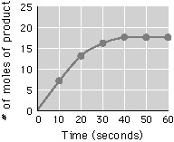

- In order to keep the rate of reaction constant over the entire time course, what should be done?
- To determine the rate of enzyme activity, an experiment is done that mixes enzyme and substrate together for 30 seconds, 60 seconds, 90 seconds and 120 seconds. After the specified times, H₂SO₄ is added to the reaction chamber. What affect would the sulfuric acid have on the experiment?

Lab – Photosynthesis

What You Must Know:
The equation for photosynthesis and understand the process.
The relationship between light wavelength or intensity and photosynthetic rate.
The anatomy of a typical leaf and how the structures interact in photosynthesis.
How to determine the rate of photosynthesis.
Science Practices – Can You:
Measure the rate of photosynthesis using a technique that gives consistent results?
Apply math to calculate the rate?
Describe the relationships of cell structure and function?
Describe strategies for capture, storage, and use of free energy by plants?

Two possible labs done for photosynthesis:
a. Floating leaf disks – leaf chads removed of O2 gas and placed in bicarbonate solution and then under light.
b. DPIP reduction technique – chloroplast membranes are broken up and then exposed to light. Electrons are boosted to higher energy level, but electron acceptors are destroyed and thus not able to function. DPIP is a chemical that will pick up the electrons from chlorophyll, reducing the chemical. When oxidized DPIP is deep blue, when reduced it will become colorless.

1. If a student uses the DPIP technique, what is the role of DPIP? How can the rate be measured?

2. Some students were not able to get many data points when using DPIP because the solution went from blue to colorless in only 5 minutes. What modification to the experiment do you think would be most likely to provide better results?

3. If a student performed this experiment using DPIP that was initially deep blue and got a flat line when the data were graphed, showing very little change, what could be a plausible explanation?

4. A student used the floating disk technique to measure the rate of photosynthesis. After 20 minutes under bright light, none of the disks had floated. Based on your understanding of photosynthesis, what might be the reason for this outcome?

5. If you removed all the gases in the leaf disks and placed the disk in water near a bright light source, what would happen?

Lab: Cellular Respiration

What You Must Know:
The equation for cellular respiration.
The components of a respirometer and how it works.
The relationship between movement of water in a respirometer and cellular respiration.
The effect of temperature or increased metabolic activity on respiration.
How to calculate rate of respiration.
Science Practices - Can you:
Design an experiment to answer a question about cellular respiration?
Analyze your data and use appropriate math to describe your results?
Justify a claim such as “ dormant seeds respire at a low rate” with evidence?

Using the graph below fill in the table for respiration rate.

Conditions | mL oxygen consumed per minute
Germinating corn @ 22 degrees Celsius
Germinating corn @ 12 degrees Celsius
Nongerminating corn @ 22 degrees Celsius
Nongerminating corn @ 12 degrees Celsius
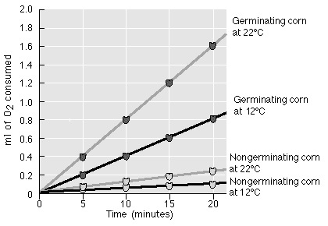
- What was the purpose of the glass beads used in the experiment?

- Explain the function of KOH in the experiment.

- The mL of oxygen consumed per minute is a direct measure of what cellular process?

- If the temperature increases, will the mL of oxygen consumed per minute increase or decrease?

Lab - Mitosis and Meiosis

What You Must Know:
The events of mitosis and meiosis in plant and animal cells.
How mitosis and meiosis differ.
How normal cells and cancer cells differ from each other.
What may go wrong during the cell cycle in cancer cells.
The roles of segregation, independent assortment, and crossing over in generating genetic variation.
How to calculate map distance from experimental data.
How to evaluate experimental results using Chi-square.
Science Practices – Can You:
Make predictions about natural phenomena occurring in the cell cycle?
Describe the events that occur in the cell cycle?
Represent the connection between meiosis and increased genetic diversity?
Use the math of Chi-square analysis

In an experiment testing mitotic rate, one group of plants were grown with water (control) and another group was grown with a chemical lectin (experimental) a protein known to increase mitotic rate. The following data was gathered:

 | Cells in Interphase | Cells in Mitosis | Total # of Cells
Control Group | 176 | 24 | 200
Experimental Group | 186 | 64

Use Chi Square to support or reject a conclusion that the treatment to the experimental group increases the rate of mitosis. (Observed values are from experimental group. Expected values are calculated from the control group percentages)

In the Sordaria lab, meiosis was studied and map units can be calculated. The arrangement of the spores determines if crossing over occurred. You must calculate % of crossovers: dividing # of crossover asci by total number of asci X100.
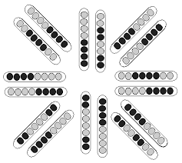
To calculate the map distance: divide the percent crossover asci by 2. (only half of the spores in an ascus are the result of crossover)
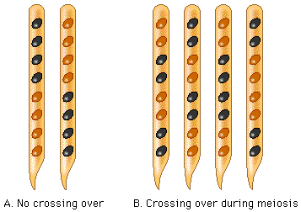
How many of the asci are showing results of crossing over?

Data Table Example
Number of Asci Counted | Spore Arrangement
7 | 4 light/4 dark
8 | 4 dark/4 light
3 | 2 light/2 dark/2 light/2 dark
4 | 2 dark/2 light/2 dark/2 light
1 | 2 dark/ 4 light/2 dark
2 | 2 light/4 dark/2 light
How many asci contain a spore arrangement that resulted from crossing over?

From this small sample, calculate the map distance between the genes?

In a given plant cell, genes A and B have a crossover rate of 33%. Genes A and C have a crossover rate of 20%.
Based on that information, which of the following statements is accurate (circle as many as apply).
- A and B and A and C are linked genes.
- A is located closer to B than it is to C.
- A is located closer to C than it is to B.
- Genes A and B are located on different chromosomes.

Lab – Molecular Biology

What You Must Know:
The principles of bacterial transformation, including how plasmids are engineered and take up by cells.
Factors that affect transformation efficiency.
How to verify and screen for transformed cells.
Bacterial transformation is a type of horizontal gene transfer and increases genetic variation.
Science Practices – Can You:
Calculate transformation efficiency and express the results in scientific notation?
Predict and justify how a change in the basic protocol for bacterial transformation would affect transformation efficiency?

In a molecular biology lab, a student obtained competent E.coli cells and used a common transformation procedure to induce the uptake of plasmid DNA with a gene for resistance to the antibiotic kanamycin. The results shown below:

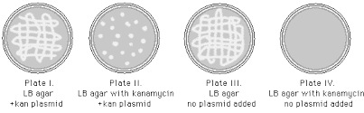
On which petri dish do only transformed cells grow? ________
Which plate is used as a control to show that non-transformed E.coli will not grow in the presence of kanamycin?_____________

During the course of an E.coli transformation lab, a student forgot tot mark the culture tube that received the kanamycin-resistant plasmids. The student proceeds with the lab because he thinks that he will be able to determine from his results which culture tube contained cells that may have undergone transformation. Which plate would be most likely to have the transformed cells?
A) a plate with a lawn of cell growing on LB agar with kanamycin.
B) a plate with a lawn of cells growing on LB agar without kanamycin.
C) a plate with 100 colonies growing on LB agar with kanamycin.
D) a plate with 100 colonies growing on LB agar without kanamycin.
Lab: Restriction Enzyme Analysis/Electrophoresis

What You Must Know:
The function of restriction enzymes and their role in genetic engineering.
How gel electrophoresis separates DNA fragments.
How to use a standard curve to determine the size of unknown DNA fragments.
Science Practices – Can You:
Apply math to construct a graph of DNA fragments of known size?
Use a standard curve to determine the size of unknown DNA fragments?
Use the results of gel electrophoresis to map the restriction sites of a bacterial plasmid?

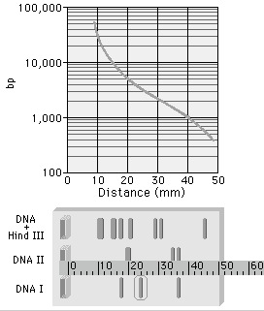
The graph shows the results for the fragments made with the HINDIII restriction enzyme. Since these fragment sizes are known, one can determine the other fragment sizes from DNA 1 and DNA 2 samples.
1. How many base pairs is the DNA 1 fragment circled in the figure to the right?
2. Why do fragments move in the gel?
3. How come some move farther than others?
This plasmid has restriction sites for two different enzymes. Several restriction digests were done using these two enzymes either alone or in combination.

4. Which gel lane shows a digest with BamHI only?

5. Which gel lane shows a digest with both enzymes?
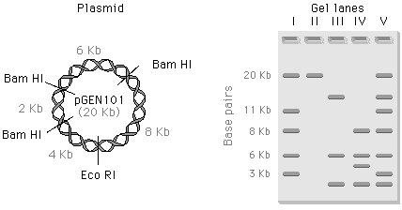

Lab – Artificial Selection

What You Must Know:
A technique to investigate selection as a mechanism of evolution.
How to apply math to data to predict what will happen to the population in the future.
Quantitative methods to determine whether the two populations are significantly different, and appropriate use of error bars, graph type and statistical tests.
Science practices – Can you:
Design a plan for collecting data that will investigate the effect of selection on a population?
Analyze your data to identify patterns and relationships?
Predict what will happen to a population in the future, based on selection type models?

The following data were obtained in an artificial selection experiment with Fast Plants.

Height (cm) Flower Generation 1 | Height (cm) Flower Generation 2
8.2 | 9.6
7.3 | 9.3
9.2 | 8.8
8.1 | 6.4
8.0 | 8.9
7.8 | 8.8
7.9 | 8.2
9.1 | 7.9
6.2 | 8.7
8.9 | 8.8

1. What is the mean height of the plants in the first generation to the nearest tenth?
2. What is the mode of the plants in the second generation to the nearest tenth?
3. To the nearest tenth, what is the percentage increase in height of plants in the second generation?

Lab – Hardy Weinberg

What You Must Know:
The HW equation and be able to use it.
Conditions for maintaining HW equilibrium
How genetic drift, natural selection and the heterozygote advantage affect HW equilibrium
Science Practices – Can you
Use a data set to reflect a change in genetic make-up in a population over time
Use math to predict how the genetic composition of a population may change due to natural selection, genetic drift, or gene flow?
Describe a model that represents evolution within a population
Evaluate data that illustrates evolution as an ongoing process

1. If the frequency of two alleles in a gene pool is 90% A and 10% a, what is the frequency of individuals in the population with the genotype Aa?

2. In a population that is in HW equilibrium, the frequency of the homozygous recessive genotype is 0.09. What is the frequency of individuals that are homozygous dominant?

3. If a population experiences no migration, is very large, has no mutations, has random mating and there is no selection, what can you predict about the evolution of the population?

4. Why was the heterozygous condition for sickle cell favorable against malaria?

Lab – Evolutionary Relationships with BLAST

What You Must Know:
Computer programs have sophisticated ways of measuring and representing relatedness among organisms.
Similarities in gene or amino acid sequences can be used to determine evolutionary relationships
Phylogenetic trees graphically represent ancestral groups and their descendants and can be drawn using many types of evidence.
Science Practices – Can You
Create a phylogenetic tree that correctly represents evolutionary history and speciation from a provided data set?

1. Suppose that species 1 and species 2 have similar appearances by very divergent gene sequences, and that species 2 and species 3 have very different appearances but similar gene sequences. Which two are more closely related and why?
2. When cytochrome c molecules are compared, yeasts and molds are found to differ by approximately 46 amino acids per 100 residues (aa in the protein). Insects and vertebrates are found to differ by 29 amino acids per 100 residues. What can one conclude in regards to common ancestry from this data?

Lab – Energy Dynamics

What You Must Know
The difference between gross and net productivity and how it can be measured.
Energy does not cycle; only matter cycles.
The relationship between photosynthesis and respiration and how theses processes relate to energy flow, NPP and ecosystem energy dynamics.
How to measure productivity to investigate energy capture and flow in an ecosystem.
Science Practices – Can You
Plan and implement data collection strategies to answer energy flow questions?
Analyze data to identify patterns or relationships?
Refine your observations and measurements and evaluate the evidence from data

1. How does the amount of dissolved oxygen increase or decrease when:
a. Temperature increases _________________________
b. Salinity of water increases ________________________
c. The number of plants in the water increases ____________________

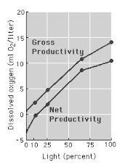
2. At what light intensity do you expect there to be no net productivity?

3. What is meant by “net productivity” and how is it calculated?

4. Why is net productivity lower than gross productivity?

5. Consider the following two ecosystems located at the same latitude:
Ecosystem A | Ecosystem B
266 sunny days/year | 183 sunny days/year
282 frost-free days/year | 125 frost-free days/year
25” rain/year | 36” rain/year
a. Ecosystem A would be expected to have less species diversity because of abundant light and long growing season.
b. Ecosystem B would have greater species diversity because it receives more water annually.
c. Ecosystem A would be expected to have the highest gross primary productivity because of more sunny days and a longer growing season.
d. Ecosystem B would be expected to have the highest net primary productivity because of longer winters and fewer sunny days.

6. As shown in the data table, as the amount of light reaching a water sample decreases, the amount of dissolved oxygen in the water sample decreases. Explain why.
% Light Reaching Water Sample | Amount of Dissolved Oxygen
100 | 4.0
65 | 2.5
0 | 0.8
Lab – Transpiration

What You Must Know:
The function of the stomata in gas exchange in plants.
The role of water potential and transpiration in the movement of water from roots to leaves.
The effects of various environmental conditions on the rate of transpiration.
Science Practices – Can You:
Predict and justify whether a plant cell will give or lose water based on water potential?
Create and annotate a diagram to show what would happen to grass planted near a road that has been salted in winter? Include water potential in explanation.

1. What is the apparatus that is used in the experiment for transpiration?

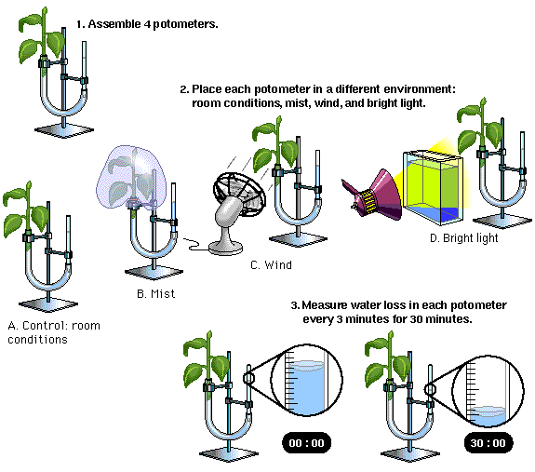
What are some factors you would need to hold constant for a valid control?

How will the transpiration rate be affected by condition B?

How will transpiration rate be affected by condition C?

How will transpiration rate be affected by condition D?

1. All of the following enhance water transport in terrestrial plants EXCEPT
a. hydrogen bonds linking water molecules
b. capillary action due to adhesion of water molecules to the walls of xylem.
c. evaporation of water from the leaves.
d. K+ being transported out of the guard cells

2. Under conditions of bright light, in which part of a transpiring plant would water potential be lowest?
a. xylem vessels in the leaves
b. xylem vessels in the roots
c. root hairs
d. spongy mesophyll of the leaves

Lab - Animal Behavior

What You Must Know:
Descriptions of various animal behaviors, such as orientation behavior, phototaxis, chemotaxis, and how the behavior is adaptive.
Science Practices – Can You:
Design a plan for collecting data to show how a particular species is affected by biotic or abiotic interactions?
Analyze data to identify possible patterns and relationships?
Apply statistical analysis to evaluate data?

1. A student wanted to study the effect of nitrogen fertilizer on plant growth, so she took two similar plants and set them on a window sill for a two-week observation period. She watered each plant the same amount, but she gave one a small dose of fertilizer with each watering. She collected data by counting the total number of new leaves on each plant and also measured the height of each plant. Which of the following is a significant flaw in this relationship?
a. there is no variable factor
b. there is no control
c. there is no repetition
d. measurable results cannot be expected

2. Students placed 5 pill bugs on the dry side of a choice chamber and 5 pill bugs on the wet side. They collected data as to the number on each side every 30 seconds for 10 minutes. After 6 minutes, eight or nine pill bugs were continually on the wet side of the chamber, and several were under the filter paper. Which of the following is NOT a reasonable conclusion from these results?
a. It takes the pill bugs several minutes to explore their surroundings and select a preferred habitat.
b. Pill bugs prefer a moist environment.
c. Pill bugs may find chemicals in dry filter paper irritating.
d. Pill bugs demonstrate no significant habitat preference.

3. If a student wanted to determine whether pill bugs prefer a moist or a dry environment, what would be a good first step in looking at the data?
a. Total the number of pill bugs on the dry side throughout the entire experiment and compare this with the number on the wet side throughout the experiment.
b. After waiting 5 minutes for the pill bugs to acclimate, count the number of pill bugs on the dry side every 30 seconds for 5 minutes and determine the total number on the dry side. Do the same for the wet side and compare data.
c. Compare the number of pill bugs on the dry side at the end of 10 minutes with the number of pill bugs on the wet side at the end of 10 minutes.
d. Divide the number of pill bugs on the dry side throughout the experiment by the number on the wet side throughout the experiment.

4. Which of the following hypotheses is stated best?
a. If pill bugs are allowed free movement, then more will be found in a moist environment than in a dry environment.
b. If pill bugs like a moist environment, then they will move to the wet side of a choice chamber.
c. If an experiment with pill bugs is run for 10 minutes then more pill bugs will be found in the most favorable environment.
d. Pill bus are found in moist habitats, so I predict that more will be found where it is wet.

